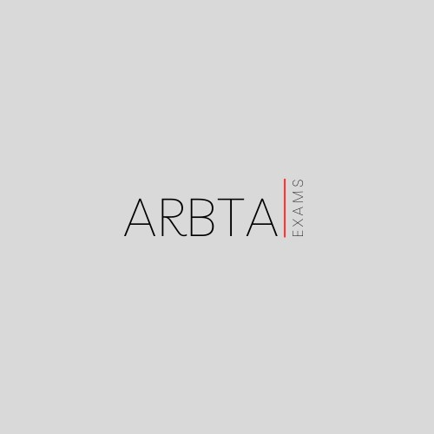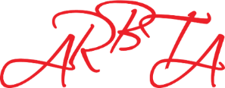 ASSOCIATION OF RUSSIAN BALLET

& THEATRE ARTS

Session Feedback Form

**In order to improve and monitor the service we provide**

**Centre Number: Examiner:**

**Session Date: Session ID:**

|  |  |  |
| --- | --- | --- |
| **Session Type** | **Enter ‘Y’ or comments in correct box** | |
| ARBTA GQAL Regulated Examination Session Only |  | |
| ARBTA Examination/Assessment Session Only |  | |
| Mixed Session of Regulated and Unregulated |  | |
| **Questions** | **Answer** | |
| 1). Did you receive your paperwork for the examination 2 weeks prior to the date of the session? |  | |
| 2). Did the examiner arrive on time? If no, please state the time of arrival. |  | |
| 3). Did the session run in accordance with the timetable? If no, please explain why |  | |
| 4). How effectively did the examiner communicate with you and your students? | Very effectively |  |
| Effectively |  |
| Fairly effectively |  |
| Not very effectively |  |
| Not effectively at all |  |
| 5). On the whole, how do you feel your examination session went? | Extremely well |  |
| Very well |  |
| Average |  |
| Not very well |  |
| Really badly |  |
| 6). Please detail below any further comments or feedback information about your examination session and/or your examiner. | | |
|  | | |